Architexa, backend access instructions:

You will first need to open the following github link to access our repository:

[Ash237333/208-Project (github.com)](https://github.com/Ash237333/208-Project)

This will show you a page like this:

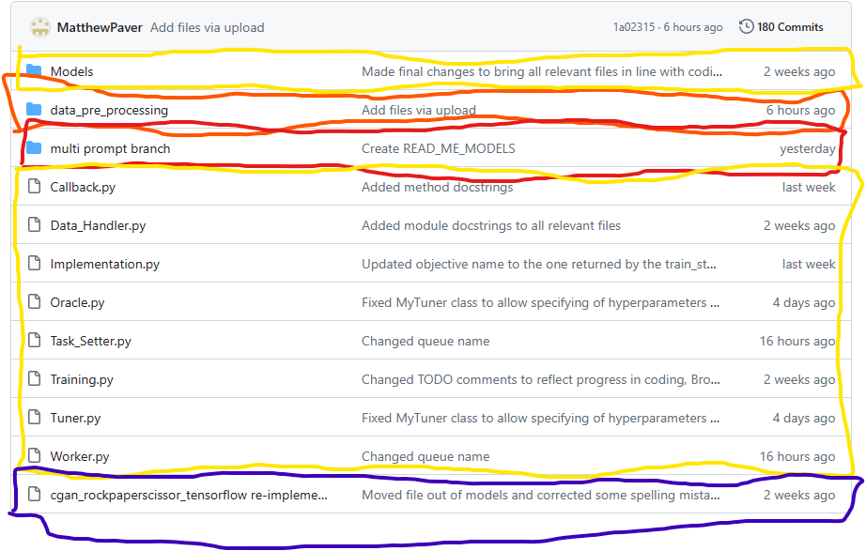

The areas in yellow are defunct branches (older complete versions, which we differentiated from in case the addition of new features broke something), and can be largely ignored.

The areas in purple are pre-written projects that we have substituted our own code in for unit testing purposes (for example the one on this page has its models replaced with earlier versions of ours, so that we could test that the models would run, before we had our training apparatus and dataset finished)

The area in orange is the dataset for the project, and does not need to be opened, unless you want to run our bulkAI scripts to generate more images. (however you do need to download it)

The area in red is the current version of the model and clicking on it will send you to this:

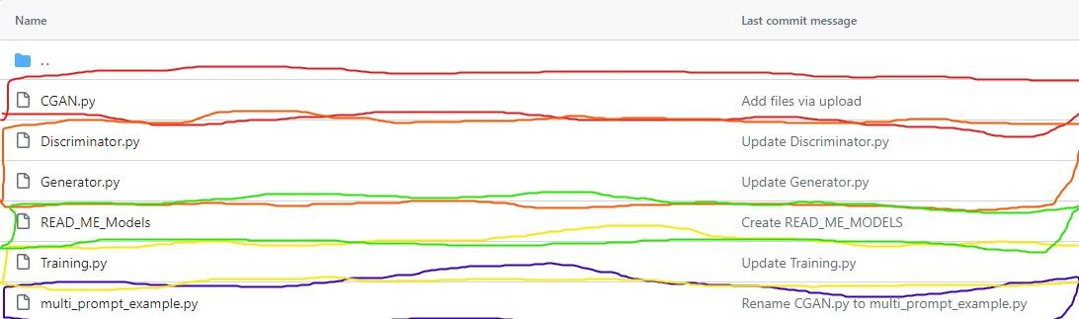

The area in purple is an example project which showsthat our implementation of multi labeling works

The area in yellow is another defunct branch

The are in green is a text file giving some explanation of the models

The area in orange are the actual neural networks. (you need to download these)

And the area in red is the main file for the project, to run the project you need to download this into the same folder as the other files then run it in python.IDLE.3.11.

In order for it to run you will also need the tensorflow python library installed, which you can get from here:

[tensorflow · PyPI](https://pypi.org/project/tensorflow/)